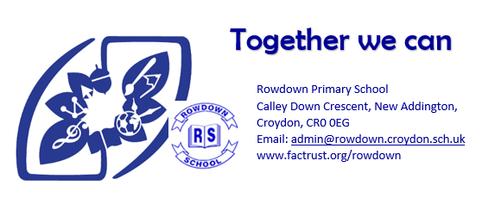
Class Teacher KS2 required

Are you passionate about primary education? Do you have the creativity, commitment, and drive to inspire young learners? Rowdown Primary School is looking for a caring and enthusiastic class teacher to join our vibrant and supportive community.
Rowdown Primary is a Good school situated in the south of the London Borough of Croydon. Our real strengths lie in personal development, inclusion, and the wide range of opportunities we provide for all our children. Our dedicated team works collaboratively to create an inclusive environment that encourages every child to achieve their potential, develop confidence, and foster a love for learning.
The Role
As a Class Teacher, you will:
- Deliver engaging and challenging lessons across the primary curriculum.
- Create a positive, nurturing classroom environment that promotes curiosity, respect, and high aspirations.
- Use a variety of strategies to meet the needs of all learners, supporting their academic, social, and emotional development.
- Work closely with families, colleagues, and the wider community to ensure the best outcomes for all pupils.
- Uphold the highest standards of safeguarding and welfare for all children.

What We’re Looking For
- Qualified Teacher Status (QTS) with experience teaching in Key Stage 2.
- A commitment to providing the best education and personal development for every child.
- Strong communication and teamwork skills.
- A reflective practitioner who is willing to learn and grow alongside our children.
- Creativity, enthusiasm, resilience, and a good sense of humour!
We welcome applications from experienced teachers as well as Early Career Teachers (ECTs).
To truly understand what makes Rowdown Primary School special, we warmly invite you to visit us. Please contact us on 01689843367 to arrange a time- we would love to meet you!
If you are passionate about working with children and want to make a real difference, there is a place for you at Rowdown Primary School. Further details are available on our website: www.factrust.org/rowdown
Rowdown Primary School is committed to safeguarding and promoting the welfare of children and young people and expects all staff and volunteers to share this commitment. An enhanced DBS and Prohibition Order check will be required before starting.
Rowdown Primary School is part of FACT Trust, a small Croydon-based multi-academy trust with inclusion at its core. are continually striving to be an inclusive employer, and are committed to building a diverse workforce where everyone feels valued, respected and able to thrive.
Start date: 1st September 2026
Contract type: Full time
Salary: MPS 1-4 depending on experience. ECTs welcome.
Contract term: Permanent
Closing date for applications: Friday 12th June
Interviews: WK beginning 15th June

