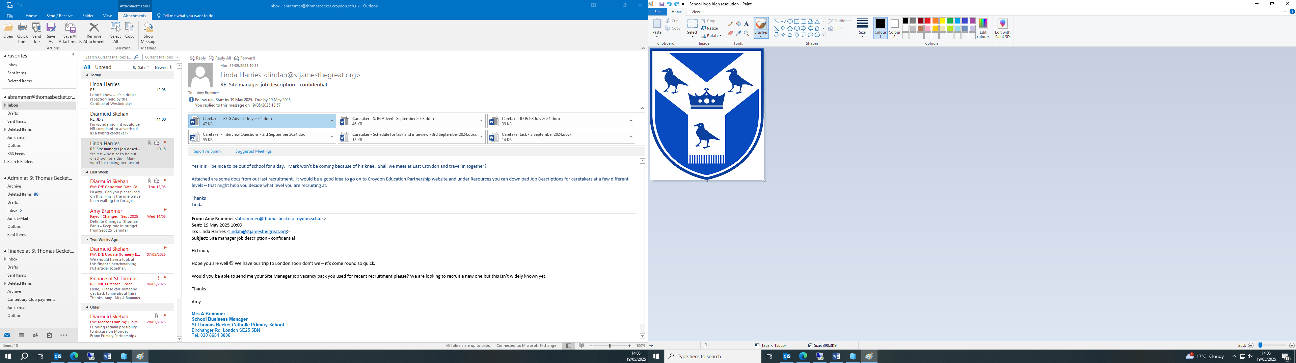

**St Thomas Becket Catholic Primary School**

We are seeking to appoint an enthusiastic, experienced and committed **School Caretaker/ Premises Manager**.

36 hours per week (Monday to Friday inclusive) Term Time only plus INSETS and up to 4 additional weeks - Exact start and finish times to be agreed**.**

Grade 6 - Scale Points 18 – 20 (£34,416 - £35,448 FTE) or Grade 7 – Scale Points 23 – 25 (£37,068 - £38,058 FTE) *Based on experience.

**Start date of 1st September 2025.**

St Thomas Becket is an inclusive, oversubscribed and successful school, seeking to appoint an experienced and highly skilled School Caretaker/Premises Manager.

Staff at St Thomas Becket have a strong network to support them and help develop or discover career opportunities. We operate an appraisal system where you have a say in what you need to develop and time to do it.

All staff are encouraged to take advantage of a wide range of high quality professional learning opportunities.

The School Caretaker/Premises Manager will work closely with and support the School Business Manager to deliver a first class service in all aspects of security, maintenance, refurbishment and cleanliness of the school and grounds for all stakeholders.

Key to your success will be:

* An understanding and knowledge of Health and Safety principles and requirements within a school setting including COSHE.
* Demonstrate knowledge of security methodology for both building and grounds without risking the health and safety of the School community.
* Full working knowledge of relevant policies, procedures and codes of practice with an awareness of relevant legislation.
* Ability to relate well to children and adults.
* Excellent DIY skills with the ability to carry out day to day repairs and maintenance of the school buildings and grounds.
* Excellent initiative and able to demonstrate the ability to manage own time effectively and establish priorities within workload.
* The ability to problem solve quickly and effectively and display a conscientious and logical approach to resolve situations that arise with stakeholders to ensure smooth running of the school.
* Ability to perform physical tasks required by the post which will include lifting, carrying and using various equipment.
* Ability to carry out administrative tasks as required including stock taking.
* Ability to drive the school minibus.
* The ability to communicate clearly with all stakeholders verbally and in writing.
* Able to support and actively promote the Catholic ethos of the school.

**St Thomas Becket is committed to safeguarding and promoting the welfare of children. Successful candidates will be required to undertake an Enhanced Disclosure via the Disclosure and Barring Service.**

**In line with the statutory guidance document Keeping Children Safe in Education (2023), the school will conduct online searches after the shortlisting process for any candidates who accept an invitation to interview**.

Further details, application form and additional recruitment forms are available from the school website - [Work for Us – St Thomas Becket Catholic Primary School](https://www.thomasbecket.croydon.sch.uk/about/school-vacancies/)

**Visits to the school are warmly welcomed and encouraged.**

Please E Mail finance@thomasbecket.croydon.sch.uk to arrange an appointment**.** If you are keen to develop professionally in an exciting, caring and supportive environment, our school is the place for you.

For an informal and confidential discussion, please contact Amy Brammer, School Business Manager on 0208 654 3006.

**Closing date: 21st June 2025**

**Interviews: Week commencing 23rd June 2025**

**WE RESERVE THE RIGHT TO CLOSE THE ADVERT EARLY AND BRING THE INTERVIEW DATE FORWARD/PUSH BACK.**

**Applications will only be considered with a completed application form.**

**E Mail your completed application form and a personal statement to:** [**finance@thomasbecket.croydon.sch.uk**](mailto:finance@thomasbecket.croydon.sch.uk) **or return the completed documents by post marked Private and Confidential for the attention of the School Business Manager.**