Class Teachers

Salary: MPS (Outer London)
Contract: Permanent, Full Time
Start Date: September 2022
Are you ready for the next step in your career and keen to progress in a Great School?
Do you have experience of working in Key Stage 1 or Key stage 2?
Dear Applicant,

Thank you for your interest in joining Keston Primary School as a class teacher. This is an exciting opportunity to be part of a great school with a dedicated and forward thinking team.

We are seeking to appoint a highly motivated and passionate class teacher with the desire to develop their own teaching skills, along with the ambition to innovate and drive standards forward. It is preferable the candidate has had teaching experience in either Key Stage 1 or Key stage 2.

Keston Primary is a two-form entry primary school located on the border of Croydon and Surrey. We are fortunate to have superb grounds with good facilities, both inside and outside. These include a swimming pool, outdoor classroom, running track, computing suite, two libraries, a dedicated music room and a pond and quad with a growing area. As well as the main school, we have a Nursery, with its own outside learning area. Our school also prides itself on developing outdoor learning and global learning opportunities; core threads running through all aspects of our curriculum. We have an ethos of inclusion and diversity and have a proven track record of supporting SEND children.

As part of PACE Academy Trust, we work alongside four other schools with the mission to provide high quality education and care in happy, inspiring environments, in which all children and adults are valued and encouraged to succeed. We work collaboratively as a trust on many key areas, with the flexibility and independence to innovate as a school.

We have a keen and enthusiastic staff who embrace risk taking and new initiatives. The quality of teaching is high and staff are dedicated to raising standards in teaching and learning.

We welcome further discussions with the Head of School and invite you to look at our website and video tour, to find out more about us. We do hope you will feel encouraged to join our dedicated and supportive team.

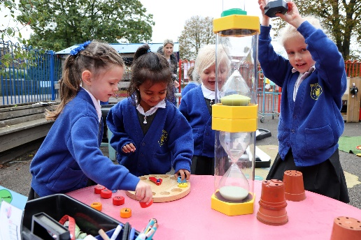
Application Details
Thank you for your interest in the class teacher position at Keston Primary School. Further details of this post and our school are included in this pack and details of how to apply, can be found below.

School Visits
We welcome visits so you can find out more about our school. If you would like to arrange a school visit, please contact the school office to make an appointment on 01737 555103. Alternatively please email office@keston.croydon.sch.uk with your details and we will contact you to arrange an appointment.

How to Apply
Should you wish to apply for the post, please complete the attached application form and submit via the eteach website.
Interviews
Interviews will be held on an ongoing basis throughout the summer term.

Safeguarding
Keston Primary School is committed to safeguarding and promoting the welfare of children, young people and vulnerable adults, and expect all staff and volunteers to share this commitment. Please be advised that this post is subject to an enhanced DBS check.

Equality and Diversity
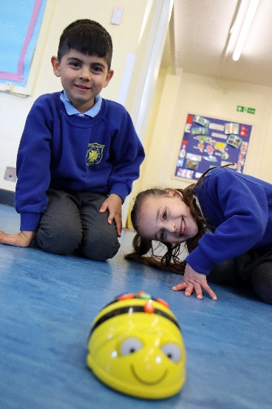
In PACE Academy Trust we celebrate our diversity and promote equality. People from diverse backgrounds are encouraged to apply. Our full commitment to equality is set out on our website https://www.paceacademytrust.com

Keston Primary School
Job Description – Class Teacher
Reporting to: Head of School and Senior Leadership Team
Teaching and Learning
- Plan, teach and provide feedback to children in accordance with the school’s agreed policies.
- Extensive knowledge of the National Curriculum, with KS2 experience being preferable
- Set homework in line with the agreed policy.
- Keep records which assist in the continuous assessment of children’s learning.
- Carry out all formative and summative assessment requirements in line with the published annual cycle, ensuring all results are forwarded by agreed dates.
- Provide information to parents about their children’s progress through parent consultation evenings, school reports and informal reports when the need arises.
- Provide a safe, effective and stimulating learning environment in accordance with the school’s display principles.
- Provide a learning environment in which all necessary resources are easily accessible to the children.

Care
- Ensure that all children have a sense of belonging and that they feel valued.
- Recognise that the class teacher is the key adult in ensuring the well-being of the children in the class, communicating any concerns to the appropriate people.
- Take action to minimise unnecessary risks in order to maintain a healthy and safe environment.
- Work with the children to achieve the school’s expectations of behaviour.
- Record information relating to the pastoral care of the children, in line with school policy.
- Be aware that teachers are role models for behaviour and that staff conduct should reflect the school’s expectations.
- Inform the Designated Safeguarding Lead (DSL) regarding any safeguarding concerns.
- Complete registers in line with requirements, notifying the Inclusion Leader of any issues.

Professional Development
- Take responsibility for your own continuing professional development
- Attend agreed training, staff meeting and INSET sessions.
- Attend courses relevant to the development needs of your curriculum area and of the school, disseminating where appropriate.
- Take part in appraisal in line with school policy.
- Fully engage in the school’s performance management system.

Other Activities
- Undertake additional duties as reasonably specified by the Head of School or Leadership Team.

Keston Primary School
PERSON SPECIFICATION – CLASS TEACHER
Qualifications and Training | Honours degree related to Primary Education or a curriculum subject  Qualified Teacher status  Enhanced DBS  Evidence of commitment to further professional development
Experience | Classroom teaching experience or teaching practice across all year groups, with particular experience in Key Stage 2
Knowledge, Skills and Abilities | Demonstrates good working knowledge of the primary national curriculum and how it links together to create academic, as well as spiritual, moral, social and cultural excellence  Proven experience of high standards of primary classroom practice  An understanding of how learning and lessons can be purposefully structured to achieve high outcomes  Innovative and inspirational, generating children’s enthusiasm through setting learning in exciting contexts, inspiring and motivating them to succeed  Uses children’s prior knowledge as a starting point for planning/teaching  Challenges and supports children across the full ability range  Uses continuous assessment within the lesson to influence and adapt teaching  Has understanding of how to make use of appropriate data to analyse the performance of children, in order to influence and adapt teaching as well as set targets  Creates a safe, happy and challenging learning environment  Can use ICT effectively  Can contribute positively to curriculum development  Communicates effectively (both orally and in writing) to a variety of audiences  An awareness of safeguarding issues
Personal Qualities | Self-motivated and hard working  Committed to, and has a strong belief in, teamwork  Keen to progress within their teaching role  Able to initiate ideas and put them into practice  Willing to embrace innovation and creativity

