Cover Supervisor

Information for Applicants

Academy The Quest Academy, South Croydon

Required 1st September, 2018

Salary £17,900 (depending on experience)

Closing Date 24th August, 2018

Interviews As applications are received.

Welcome
Dear Applicant

A very warm welcome to the Quest Academy. We are a great place to begin or further your teaching or support staff career.

At the Quest we know that having great people is our biggest asset and we work very hard to make sure that the posts we offer, the professional development we provide and the environment we create are the cornerstones of a highly successful Academy on a journey from ‘good' to ‘outstanding'.

As a new or experienced colleague you’ll be joining an Academy which has already demonstrated considerable success. In the main Academy all of our students make excellent progress above the national average by the end of Year 11 (Our Progress 8 figure overall was +0.46 in 2017 and in our thriving Sixth Form, Quest6, all of our students pass every subject (100% A*-E in 2015, 2016 and 2017) with a quite remarkable 55% A*-B and 32% A* or A in 2016) and an impressive record of sending almost every student to University, including Oxbridge.

I know that the atmosphere in the Academy and the climate in the classroom are key considerations for staff. At the Quest we have created a disciplined environment where you can share the passion of your vocation with well-behaved and curious learners. Levels of attendance are above the national average because our students enjoy coming to school and we have very well crafted systems of support in place to make sure there is no distraction from learning in the classroom.

We also believe we are outstanding in the support we provide for staff development. We have achieved the 'CLPD Gold Mark' for our professional development work. We run in-house training sessions every week to update and further our colleague’s skills and we offer part time taught Masters and Doctorate programmes with Christ Church Canterbury University for more experienced teaching staff. In addition, for newly qualified teachers we are one of the founding members of the 'Croydon Hub' which with three other local schools provide a comprehensive professional studies programme each week to help further those skills learnt in training. We also participate in the Schools Direct programme with the two Teaching School Alliances we are members of. There really are unparalleled opportunities available to those joining our teaching team.

We are also very fortunate to occupy a stunning 17 million pound building with extensive grounds which we moved into in 2014. Every teaching area is brand new and across the campus we have invested in nearly one million pounds of cutting edge IT equipment to support learning.

Geographically we are ideally located just 15 minutes from the M25, forty minutes from central London by train and Croydon itself is undergoing major investment as a place to work and live. Rents are relatively low for London and the town centre, with venues such as Boxpark and the Southend restaurant quarter, mean there is always something to do.
I do hope that our vacancy will be of interest to you. We welcome visits at any time to see us at work so that we can show you all of this in person.

With best wishes
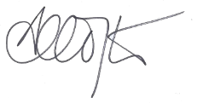
Mr A Crofts
Principal
Key Information

The Quest Academy is committed to ensuring that each student succeeds academically and personally. Our motto, Learning Changes Lives (Eruditio Vitas Commutat) reflects our belief in the importance of our work. We are committed to making sure that every student makes outstanding progress. We have high expectations of every student, offer the best quality teaching and insist on the highest standards of behaviour and respect.
The Quest is a positive, rich and innovative learning environment where every student can achieve excellence in all that they do, in the classroom and beyond it.
We offer a wide range of enrichment activities to extend learning in a range of contexts and promote leadership, teamwork, reflection, confidence and high self-esteem.
We are constantly searching for new ways to encourage participation and service to others as the basis for the development of lifelong learning and a happy and successful life.
Our strength comes from strong partnerships: with our parents, the community we serve and the close links we have with our sponsor. Together we have extensive experience and expertise to guide our work.

You can find out more information about our school, and our Trust at the following websites:

www.thequestacademy.org www.tct-academies.org

Information about The Collegiate Trust

Our Trust works in the Crawley and Croydon areas with a clear vision to deliver exceptional education for all. Such an education achieves excellent outcomes in pupil progress and attainment, a rich creative, cultural and physical learning experience, and great personal and social development for all pupils. We achieve this by working with and developing strong teams of staff in each school, under the direction of the Principal of the school and the Local Governing Body (LGB)
The Trust has grown out of Riddlesdown Collegiate, an outstanding (OFSTED, May 2016) secondary school in Croydon with almost 2000 students and over 200 staff. Gossops Green, in Crawley, was the next school – and the first primary – to join the Trust, followed by Waterfield Primary (also in Crawley) on 1st March 2018. We also have approval to develop a primary free school in Croydon / Sutton, and we shall also welcome The Quest Academy, Courtwood Primary and Gilbert Scott Primary into the Trust over the coming months.
Each school within the Trust is supported centrally by a designated Director of School Improvement on teaching and learning issues, the Chief Operating Officer, Finance Manager & HR Manager on business management and HR issues, and the CEO on wider leadership issues. This complements rather than replaces in-school functions and allows the Principal and LGB to operate with a high level of autonomy in delivering the highest standards in their school. The LGB works to a Scheme of Delegation approved by the Trust’s Board of Directors.
Our Values

Strong moral values underpin the ethos of The Quest Academy. We welcome students from a wide range of cultural and faith (or non-faith) backgrounds and expect all families to value and support the moral values at the heart of all aspects of life at The Quest Academy.
We foster understanding, tolerance and mutual respect whilst producing confident, capable and respectful young people. At all times, we aim to create an environment that nurtures and develops:
- Integrity
- Compassion
- Respect
- Tolerance
- Kindness
- Courage
- Generosity
- A life-long love of learning
These values make The Quest Academy a positive and inclusive community in which all students feel safe, valued and part of the family.

Quest6

Students at The Quest Academy’s 6th Form, Quest6, have excelled across the range of courses that are on offer. For three years running, students have achieved a 100% pass rate at A Level and every single Sixth Form student has now gone on to further study.
In addition to academic excellence, Quest6 is a positive, rich and innovative learning environment where every student can achieve excellence in all that they do, in the classroom and beyond it. We offer a wide range of enrichment activities to extend learning in a range of contexts and promote leadership, teamwork, reflection, confidence and high self-esteem.
Students at Quest6 (and staff) have access to cutting-edge, state-of-the-art facilities that – for at least the foreseeable future – are arguably the best that Greater London has to offer. A dedicated social study area, seminar-style teaching rooms, brand new technology as well as access to all of Quest’s new buildings ensure that current and future Quest6 students will learn in a modern, peaceful, exceptional education environment.

Job Description

Job Title: Cover Supervisor
Responsibility Level: £17,500
Accountable To: Principal, Principal & Governing Body
Responsible To: Attendance and Cover Manager

Accountable For:
Ensuring that the areas of Academy life for which I am responsible contribute to outcomes above expectations for the Academy students, especially in the standards they attain and the progress and achievement they make.

Understanding, operating and developing the ethos of the Academy so that it becomes a centre of excellence where mutual respect, tolerance, care and support are evidenced in all of the Academy’s activities and that this in turn ensures that everybody takes pride in all aspects of the Academy’s work.

RESPONSIBILITIES

Overall Responsibility
- To supervise cover lessons when Teachers are absent.
- To assist with administration, display and classroom tasks when not covering lessons.
- To assist with teacher photocopying as necessary
- To contribute to the safeguarding and promotion of the welfare and personal care of children and young people with regard to the Every Child Matters agenda and Area Child Protection Procedures.

DUTIES
In the context of this job description the term ‘cover’ refers to those occasions when the normal classroom Teacher is absent leaving a teaching group without a Teacher. Absence can be planned, i.e. where a Teacher’s absence is known in advance, or unplanned, i.e. where the Teacher’s absence is for unexpected medical or personal reasons.
- Cover for short term planned or unplanned absence of a Teacher by taking registration and supervising lessons. In all cases work will have been set, either by the ‘absent’ member of staff or the appropriate Team Leader.
- Manage the students’ behaviour in line with Academy policies, thus ensuring learning continues to take place.
- Report, as appropriate and in line with Academy policies and procedures, any problems such as incidents of unacceptable behaviour during the lesson.
- Report any problems with the set work to the Team Leader – especially if it is below an agreed standard.
- Help students during a lesson to complete tasks set either through supporting self-directed study or assisting students by responding to their questions.
- Collect all work done during the lesson retaining it until it can be passed onto the class Teacher, via the agreed route, upon their return.
- Work with Teachers and Team Leaders to plan cover work for an absence known in advance, and prepare a bank of materials available for unexpected absence.
- Work with Teachers in the development of educational initiatives by supporting those initiatives in the classroom

Other Duties.
- Assist in the supervision of examinations, both public and internal.
- Provide administration support for Teachers, assist with classroom displays and other management tasks as directed.
- During periods when cover is not needed, work as a Teaching Assistant under the direction of the SEND Manager.
- Set a good example in terms of personal presentation, attendance and punctuality.

Health and Safety
- Undergo Basic First Aid training and update courses.
- Be aware of the responsibility for personal Health, Safety and Welfare and that of others who may be affected by your actions or inactions.
- Co-operate with the employer on all issues to do with Health, Safety and Welfare.
- Manage the students Health and Safety, taking appropriate action related to any problems or emergencies that occur during the lesson.

Continuing Professional Development
- Participate in an induction programme that includes lesson observations of experienced Teachers and application and use of Academy policies and procedures.
- In conjunction with the line manager, take responsibility for personal professional development, keeping up-to-date with research and developments related to Academy efficiency, which may lead to improvements in the day-today running of the Academy.
- Undertake any necessary professional development as identified in the Academy Improvement Plan taking full advantage of any relevant training and development available.
- Undergo appropriate training to support the delivery of “specified work” in order to develop skills for the post.
- Maintain a professional portfolio of evidence to support the Performance Management process – evaluating and improving own practice.

OTHER REQUIREMENTS
- To promote and safeguard the welfare of children at the Academy.
- To maintain confidentiality at all times.
- To be aware of and adhere to all Academy policies and procedures.
- To carry out any other duties as may be reasonably required by the Principal.
- To work in support of the Academy Improvement Plan.
- To take time to read notices, keep to deadlines and carry out duties to the best of your ability.

Person Specification

Qualifications
Good honours degree
Qualified Teacher Status
Experience
Effective working with young people of a range of ages and abilities
Evidence of making an effective contribution to a team
Skills and Attributes
Ability to deliver high quality learning over time to all students in the subject area
Ability to be an effective Tutor
Capacity to work alongside colleagues, contributing effectively to a team
Ability to quickly establish and maintain positive relationships with students, staff and families
Understanding of safeguarding issues and promoting the welfare of children and young people
Well-developed communication skills, including high level of written and oral literacy and competent ICT use
Suitability to work with children
Potential for professional progression
Commitment to extra-curricular activities

The Collegiate Trust is committed to safeguarding and promoting the welfare of children and expects all staff and volunteers to share this commitment.

Applicants must be willing to undergo child protection screening appropriate to the post, including checks with past employers and the Disclosure and Barring Service.

Appointment will be dependent upon further health, medical and attendance checks.

Schedule for Appointment

Advert {insert date}

School Visit {insert date}

Closing Date {insert date}

Invitation to Interview {insert date}

Interview {insert date}

How to Find Us

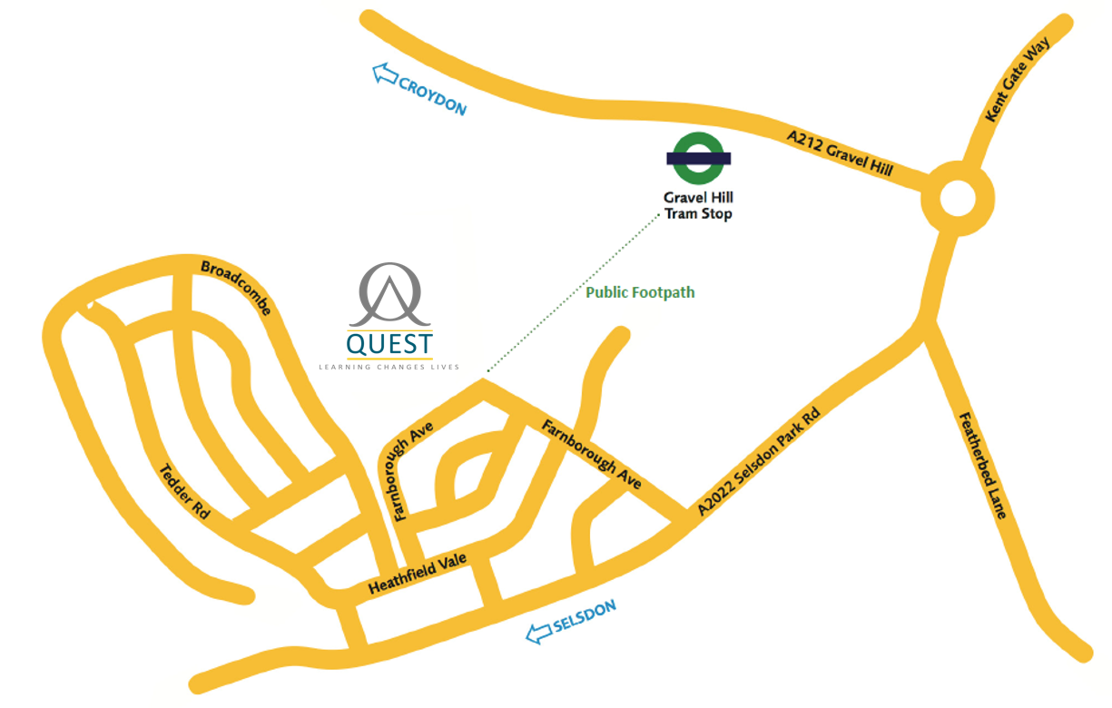

By Car:
If you are travelling by car, The Quest Academy is located on Farnborough Avenue which is off of the A2022, Selsdon Park Road. If you are coming from the M25 junctions 7 (Croydon), 6 (Caterham) or 4 (Orpington) provide easy access to Selsdon.
By Train
The nearest mainline station is East Croydon. You can then take either a number 3 tram (toward New Addington) and alight at Gravel Hill or one of the several buses that serve the area; 433, 130 or 466.

By Tram
There is a wide footpath (keep to the right hand side) which runs from the tram stop past the back of John Ruskin College, Gilbert Scott Primary School and Red Gates School, finishing in the corner of Farnborough Avenue. This walk takes about 12mins. The Academy is located on the right hand side in Farnborough Avenue.

By Bus:
Bus routes: 433, 64, 130, 466, 359.
A Gilbert Scott Primary School
Farnborough Avenue, Croydon CR2 8HD
T 020 8657 4722
E admin@gilbertscott.croydon.sch.uk
W www.gilbertscott.croydon.sch.uk
The Quest Academy
Farnborough Avenue, South Croydon, CR2 8HD
020 8657 8935
office@thequestacademy.org
www.thequestacademy.org

