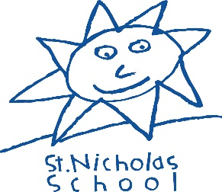

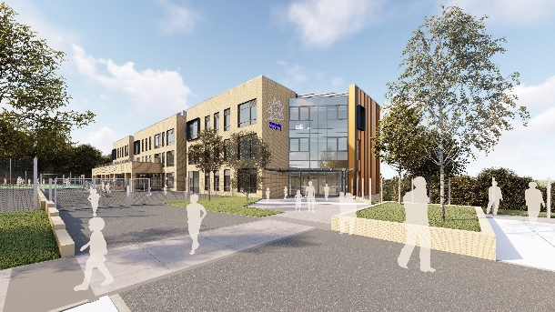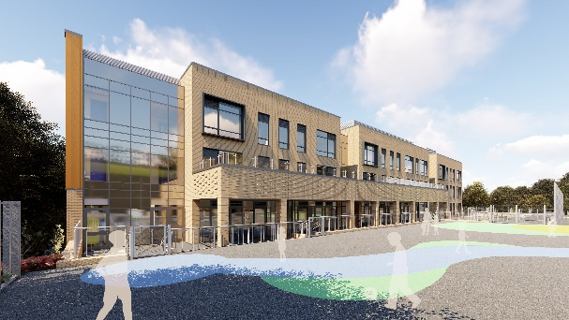

Class Teacher – St Nicholas School

Are you ready for your next step in special education?
Job Title: Class Teacher
Position type: Permanent
Contract type: Full time
Salary: Leadership scale MPS Outer London allowance + SEN allowance dependent on responsibilities and experience

Closing date: Monday 21st June 2021 at 9am
Shortlisting: Wednesday 23rd June 2021
Interview date: Tuesday 29th June 2021
Start date for start: Thursday 2nd September 2021

This is a marvellous opportunity for an inspiring Teacher to join our school on our exciting journey into our state of the art new school building.

St Nicholas is a popular choice for parents of children with special needs in Croydon.
We are rated as a Good school by Ofsted (2017).

Are you:
- an excellent Primary or Special School Class Teacher with a creative approach?
- committed to inclusion and personalised learning for EVERY child?
- an excellent communicator and team player?
- experience of children with special needs including autism, moderate or severe learning difficulties and speech and language difficulties?

We can offer:

- Excellent career opportunities to work within a vibrant and successful special school on the verge of major expansion
- An ambitious, successful and vibrant place to work
- A supportive working culture that focuses on positive learning behaviour and high expectations for all children.

Safeguarding Statement

The school is committed to safeguarding and promoting the welfare of children and expects all staff to share this commitment. We are an equal opportunities employer and we welcome applications from people with disabilities. The school will request references in advance once shortlisting has taken place. Any offer of appointment will be subject to pre-employment checks including an enhanced DBS (safeguarding) check and satisfactory references. A pre-employment medical questionnaire and completion of documents concerning disqualification of association and other various induction procedures.
References will be requested after shortlisting and before interviews. Applicants should be aware that their current or most recent employer will be approached should they be named as a referee. Please ensure that you provide an email address and telephone number for each referee.
GDPR statement
In line with the General Data Protection Regulation (GDPR) and the expected provisions of the Data Protection Act 2018 (DPA 2018) the school is responsible for holding and protecting personal data. The school is required to share some data with the Local Authority and the DFE. For further information on who we share data with please see our website for our Data Protection Policy and Privacy Notice for Applicants:
www.st-nicholas.croydon.sch.uk

Applicants should apply by using the 3 documents attached to the advert only. CVs will not be accepted. Please include a supporting document (no more than 2 A4 sheets) explaining why you feel you are able to do the job based on your skills and experience with your application form and return by the closing date to suem@st-nicholas.croydon.sch.uk

